**TRAFFIC MANAGEMENT**

**PROBLEM STATEMENT:**

Traffic congestion problems consist of incremental delay,vehicle operating costs such as fuel consumption, pollution emissions and stress that result from interference among vehicles in the traffic stream, particularly as traffic volumes approach a road’s capacity.

**PROBLEM IDENTIFIED:**

Traffic congestion, road safety hazards, inefficient public transportation, environmental pollution, inadequate infrastructure, lack of data-driven decision-making, traffic rule violations, and insufficient pedestrian infrastructure pose significant challenges to traffic management systems.

**INTRODUCTION:**

In the face of rapidly growing urbanization and increasing vehicular traffic, effective traffic management systems have become indispensable for modern cities. Traffic congestion, accidents, and environmental pollution have reached critical levels, necessitating innovative solutions to ensure the smooth flow of traffic, enhance safety, and reduce environmental impact. The Traffic Management System (TMS) project aims to address these challenges by leveraging advanced technologies and data-driven approaches.

**LITRATURE SURVEY**

**1.Monitoring and predicting traffics in cities:**

Monitoring and predicting traffic in cities involves analyzing various data sources, such as traffic flow, weather conditions, and historical patterns. Advanced technologies like GPS, sensors, and machine learning algorithms are used to collect and process this data. Predictive modeling techniques can then forecast traffic congestion, helping cities optimize traffic flow and reduce congestion by implementing data-driven strategies and real-time interventions.

**2.Overview of IOT based traffic management:**

IoT-based Traffic Management leverages sensors and data analytics to monitor real-time traffic conditions. Smart devices collect data, analyze traffic patterns, and enable dynamic interventions like adaptive traffic signals and route optimization. This data-driven approach enhances traffic flow, reduces congestion, improves emergency response, and promotes sustainable urban mobility.

**3.IOT based traffic management monitoring system:**

An IoT-based Traffic Management Monitoring System uses sensors to collect real-time traffic data. This data is sent to a central server, where it's analyzed. Authorities can monitor traffic flow, implement smart interventions like adjusting signals, and predict congestion. The system enables quick emergency response, reduces congestion, and promotes eco-friendly urban mobility.

**4.IOT based traffic management system monitoring and predicting system:**

An IoT-based Traffic Management System combines sensors and data analytics to monitor real-time traffic conditions. It collects data through sensors, processes it using advanced algorithms, and enables authorities to monitor traffic flow instantly. Additionally, the system predicts congestion patterns, allowing proactive management. This technology enhances traffic flow, reduces congestion, and facilitates efficient urban mobility.

**5.IOT based traffic management system in developed cities:**

In developed cities, IoT-based Traffic Management Systems use sensors and real-time data analytics to optimize traffic flow. Smart traffic signals, predictive analytics, and efficient emergency responses are key features. These systems enhance mobility, reduce congestion, and promote a greener urban environment.

**6.IOT based traffic management system in developed cities:**

In developed cities, IoT-based Traffic Management Systems use sensors and real-time data analytics to optimize traffic flow. Smart traffic signals, predictive analytics, and efficient emergency responses are key features. These systems enhance mobility, reduce congestion, and promote a greener urban environment.

**DESIGN THINKING**

**DESIGN THINKING APPROCHES**

**1.Empathize:**

* Understand the challenges faced by commuters, traffic police, and city officials.
* Conduct interviews, surveys, and observations to gather insights into traffic patterns and issues.

**2.Define:**

* Clearly define the problems and pain points identified during the empathizing phase.
* Create a detailed user persona for different stakeholders to understand their specific needs and expectations.

**3.Ideate:**

* Organize brainstorming sessions with a diverse group of people to generate innovative ideas.
* Encourage out-of-the-box thinking to explore various IoT technologies and solutions for traffic management.

**4.Prototype:**

* Develop a prototype of the IoT-based traffic management system using sensors, cameras, and communication devices.
* Use rapid prototyping techniques to create a working model that demonstrates the core functionalities of the system.

**5.Test:**

* Implement the prototype in a real-world traffic scenario or a controlled environment to gather feedback.
* Collect data on system performance, user experience, and any issues encountered during the testing phase.

**6.Iterate:**

* Analyze the feedback and identify areas for improvement.
* Make necessary adjustments to the system design, considering both technical and user experience aspects.
* Continue testing and iterating until the system meets the desired level of efficiency and user satisfaction.

**THE PROJECTS OVERVIEW**

**Project Overview:**

The IoT-Based Traffic Management System is an innovative solution designed to address the challenges associated with urban traffic congestion and inefficient traffic flow. By integrating Internet of Things (IoT) devices, real-time data analytics, and smart algorithms, this project aims to create a comprehensive and adaptive traffic management infrastructure. The system will monitor, analyze, and optimize traffic patterns, leading to reduced congestion, improved safety, and enhanced overall urban mobility.

**Key Objectives:**

* **Real-time Traffic Monitoring:** Deploy IoT sensors and cameras across key traffic points to capture real-time data on vehicle movement, traffic density, and road conditions.
* **Intelligent Traffic Analysis:** Utilize advanced analytics and machine learning algorithms to process the collected data, identify traffic patterns, and detect congestion in real time.
* **Dynamic Traffic Control:** Implement adaptive traffic signal control mechanisms based on real-time analysis, allowing for dynamic adjustment of signal timings to optimize traffic flow.
* **Smart Route Guidance:** Develop a user-friendly mobile application and digital signage system that provides real-time traffic updates, alternative route suggestions, and estimated travel times to help commuters make informed decisions.
* **Predictive Maintenance:** Monitor the health of traffic infrastructure (such as signals and sensors) using IoT sensors, enabling predictive maintenance to prevent system failures and downtime.
* **Emergency Response Integration**: Integrate emergency response protocols, allowing for swift detection of accidents or emergencies and enabling rapid response by authorities and emergency services.
* **Data Security and Privacy:** Implement robust security measures to protect the integrity and privacy of the collected data, ensuring compliance with relevant data protection regulations.

**Technological Components:**

* **IoT Sensors:** Deploy a variety of sensors, including vehicle detectors, environmental sensors, and surveillance cameras, to collect real-time data.
* **Communication Protocols:** Utilize secure communication protocols such as MQTT or HTTPS to transmit data from sensors to the central server and back to control devices.
* **Cloud Infrastructure**: Utilize cloud-based platforms for data storage, processing, and analysis, enabling scalability and accessibility.
* Data Analytics and Machine Learning: Employ advanced analytics and machine learning algorithms to process the data, predict traffic patterns, and optimize traffic signal timings.
* **User Interface:** Develop a user-friendly web dashboard and mobile application for both commuters and traffic management authorities, providing real-time updates and insights.

**Expected Outcomes:**

* **Improved Traffic Flow:** Reduce congestion and enhance the overall flow of traffic by dynamically adjusting signal timings based on real-time data analysis.
* **Enhanced Safety:** Improve road safety by quickly identifying and responding to accidents, breakdowns, or adverse weather conditions.
* **Efficient Urban Mobility:** Provide commuters with accurate, real-time information, enabling them to choose the fastest and least congested routes, thereby reducing travel time and fuel consumption.
* **Data-Driven Decision Making:** Enable traffic management authorities to make informed decisions based on data-driven insights, leading to more effective urban planning and policy formulation.
* **Sustainable Urban Development:** Contribute to sustainable urban development by minimizing traffic-related environmental impact, such as air pollution and greenhouse gas emissions.

**IOT DEVICE SETUP:**

**Hardware Components:**

* IoT devices (e.g., Raspberry Pi, Arduino, or specialized traffic sensors)
* Cameras for video feed
* Sensors for detecting vehicle presence and counting
* LED displays for traffic signals
* Communication modules (e.g., Wi-Fi, LoRa, or cellular) for data transmission

**Software Components:**

* Embedded software for IoT devices to collect and transmit data
* A central server to receive and process data
* Database for storing traffic data
* Web-based dashboard for real-time monitoring and control

**Technologies:**

* Programming languages (e.g., Python, C/C++)
* IoT frameworks (e.g., Raspberry Pi OS, Arduino IDE)
* Web development (HTML, CSS, JavaScript)
* Web frameworks (e.g., Node.js, Django, Flask)
* Databases (e.g., MySQL, PostgreSQL, MongoDB)
* Communication protocols (e.g., MQTT for IoT communication)
* Machine learning for traffic pattern analysis (optional)

**STEPS:**

**AUTDINO:**

**CAMERA:** 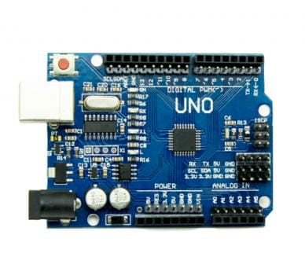

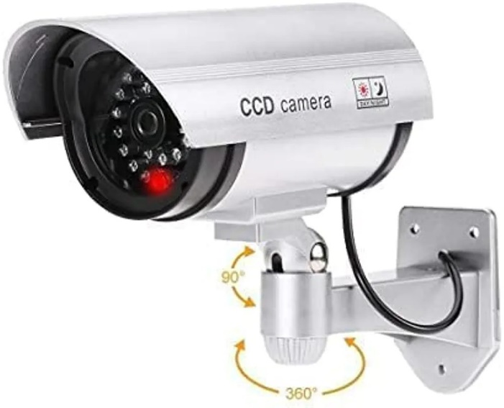

**OBJECT SENSOR:**

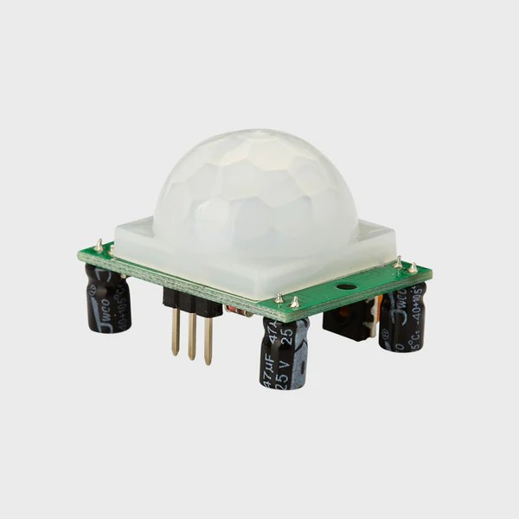

**LED DISPLAY FOR TRAFFIC SINGNAL:**

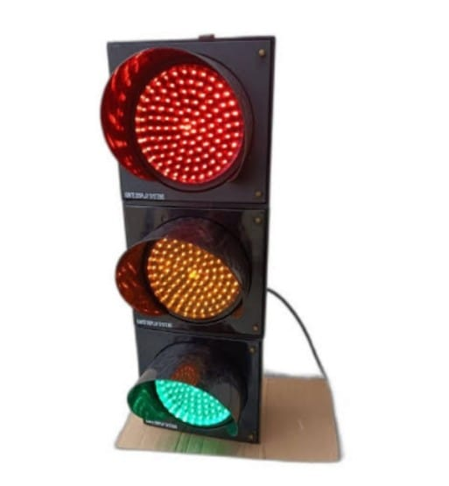

Here's a simplified example of what a component of the web-based dashboard might look like in HTML and JavaScript**:**

**CODE IMPLEMENTATION**

<!DOCTYPE html>

<html>

<head>

<title>Traffic Management Dashboard</title>

</head>

<body>

<h1>Traffic Management System</h1>

<div id="trafficData">

<p>Current Traffic Status: <span id="trafficStatus">Loading...</span></p>

</div>

<script>

// Use JavaScript to fetch and update real-time traffic data from the server

const trafficStatusElement = document.getElementById("trafficStatus");

function updateTrafficStatus() {

// Fetch traffic status from the server via API

// Update trafficStatusElement with the fetched data

}

// Periodically update the traffic status (e.g., every few seconds)

setInterval(updateTrafficStatus, 3000);

</script>

</body>

**OUTPUT:**



**Code Overview:**

**1.Setup Function:**

Initializes pins for input and output, setting the initial state of components and initiating serial communication for debugging.

**2.Loop Function**:

Continuously reads the traffic level from the object sensor. If the traffic level surpasses a predetermined threshold (200 cm), the code activates the relay to start, turns on the LED to indicate the operational status, and control the traffic .

**HTML Interface:**

**1.Status Display**:

Provides information on the current status of the traffic, whether it's actively running or stopped, allowing users to visualize its condition.

**2.Distance Measurement:**

Displays the measured traffic level (distance) detected by the object sensor.

**3.Control Buttons:**

Offers users the ability to start or stop the traffic via the web interface by clicking on the corresponding buttons.

**Objective:**

❖ The project’s primary objective is to create an IoT-based traffic management system that can autonomously regulate its operation according to the traffic level, facilitated by the object sensor

❖ This project hardware integration, sensor data processing, and user interface development to form a comprehensive system for managing a traffic management in a smart and remotely accessible manner.

**CONCLUSION:**

In conclusion, effective traffic management is crucial for ensuring the safety, efficiency, and sustainability of our transportation systems. By implementing smart technologies, promoting public awareness, and investing in infrastructure, we can mitigate traffic congestion, reduce accidents, and minimize environmental impact. Collaborative efforts between government authorities, urban planners, and citizens are essential to creating a seamless and well-functioning traffic management system that benefits everyone in the community.